Address Book Conversion Procedure Using Dawn

- Open Outlook select tools and click Address Book.

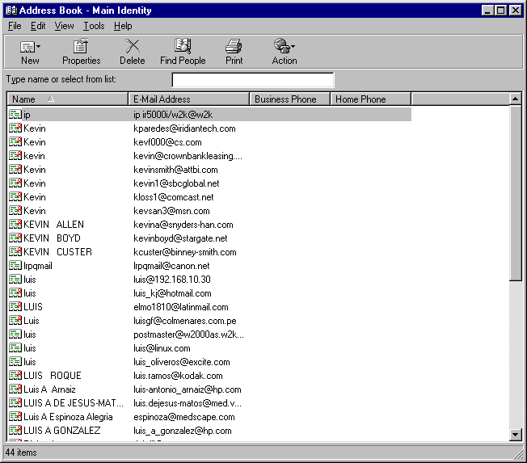

- Select file, Export and click Address Book (wab)

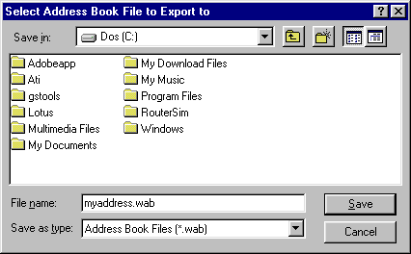

- Select the path, enter the file name and click Save.

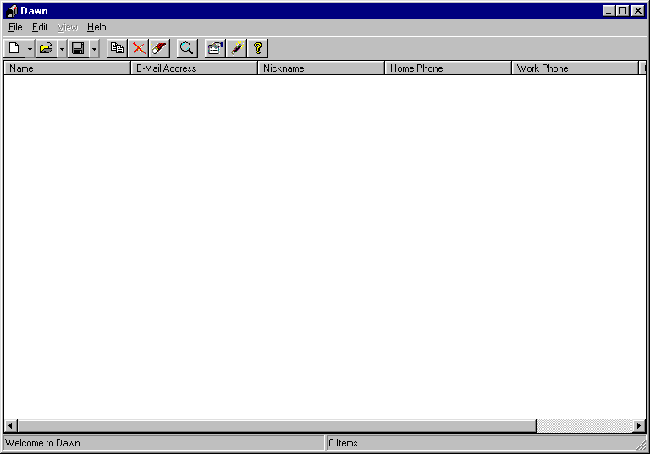

- Open Dawn and select file, open and click Open Address Book.

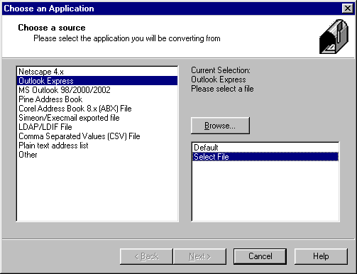

- Select Outlook Express and click “Select file” option.

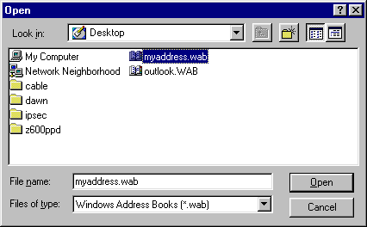

- Select the file you created on step 3 and click Open

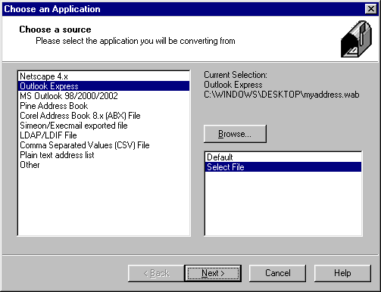

- Click Next to open the Address Book

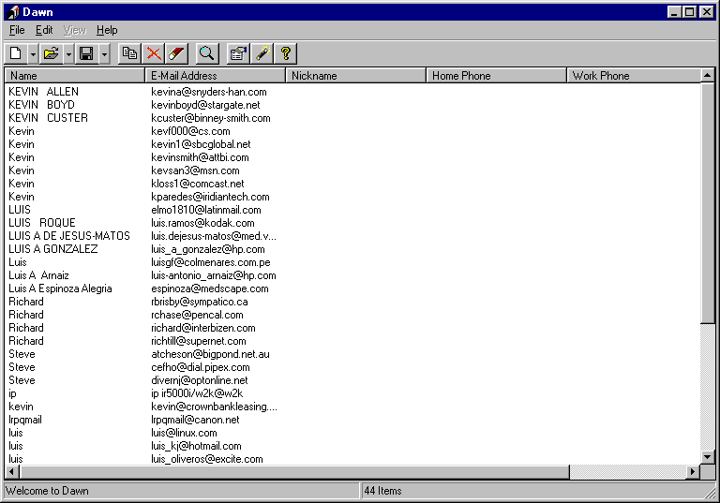

- Select file, save and click Export into Address Book option.

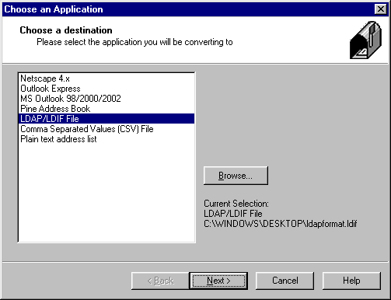

- Select LDAP/LDIF File as the application and click the Browse button to find the location and also to enter the file name of the new LDAP file.

- Click next to create the LDAP/LDIF File.

- After you finish creating the LDAP file, open Remote UI and select Additional Functions

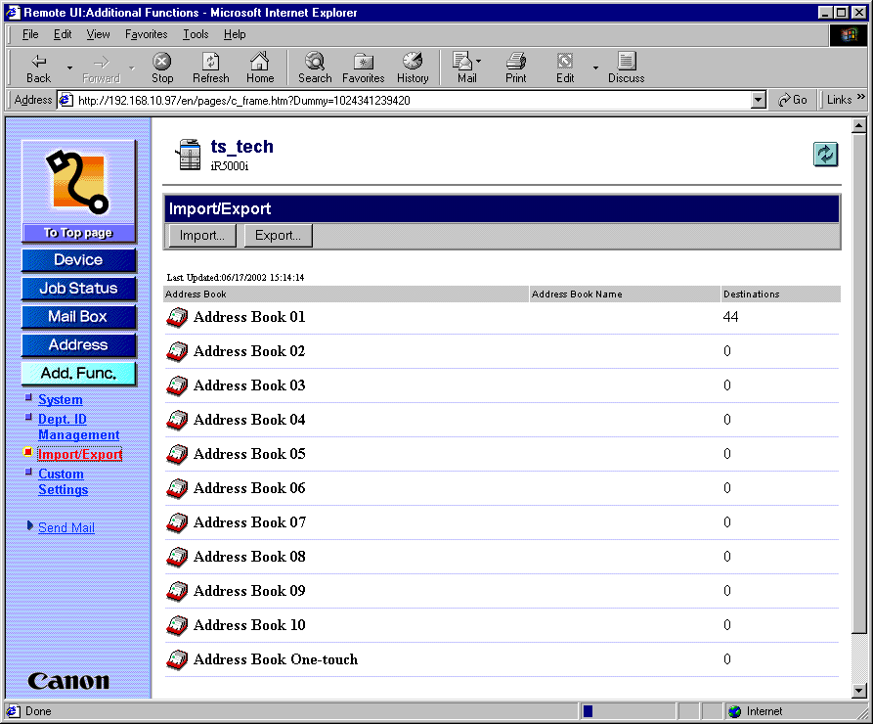

- Select Import from the import/export frame.

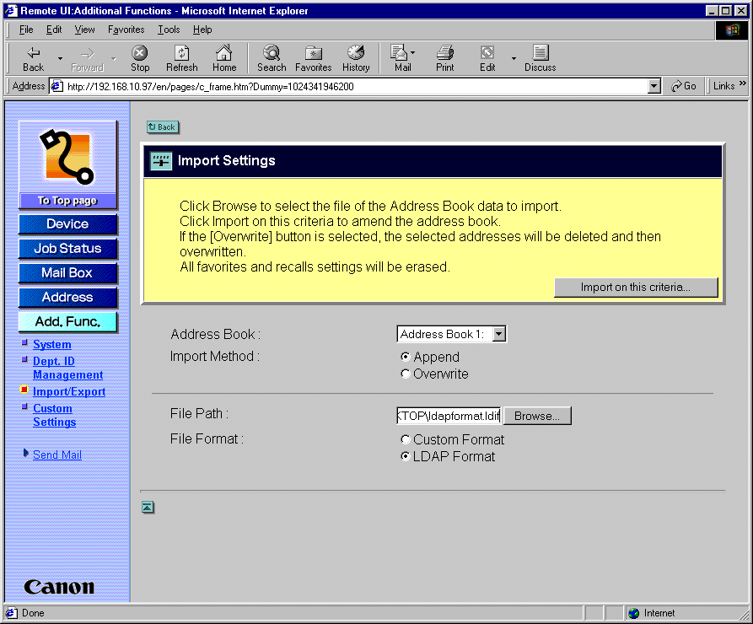

- Select the Address Book you want to use, Browse to the file you created in step 8 and also check the LDAP format ratio button.
- Click on Import on this criteria button to import the address book.

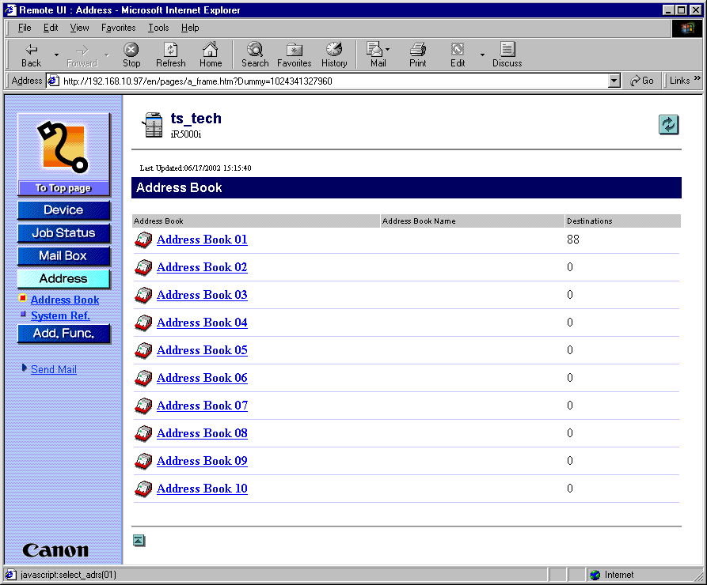

13. Click on the Address button and select the proper Address Book, you will find the new entries.

